University of Technology, Jamaica

Faculty of Engineering and Computing

School of Computing and Information Technology (SCIT)

Module Name: Introduction to Human Computer Interaction

Module Code: 3023

Tutor: Nadine Maitland

.

**Authors:**

Jade Robinson -1701077

Michael Jones -1604149

Andre Cameron -1701496

Due Date: February 23, 2021

**a. Content Model, as practiced in Usage-Centered Design**. If you did not make essential use cases in the requirements phase, do it now. Map your use cases to contexts, trying to minimize the number of contexts while not making them too complex. Give a navigation map if there is more than one context. Show the content model to users to verify that they make sense.

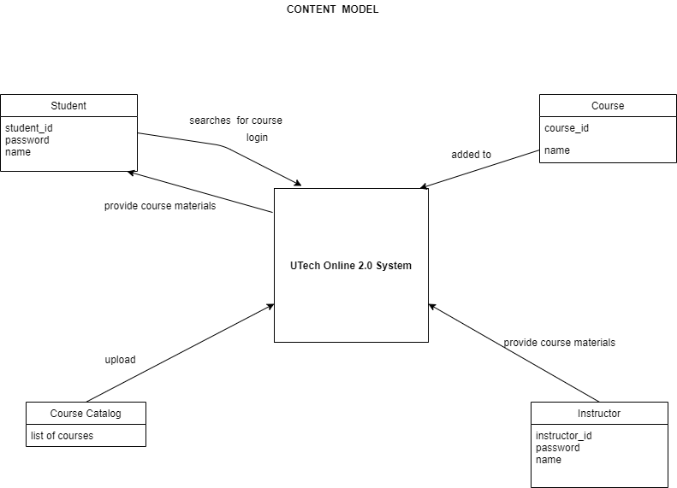

**b. Activity Scenarios, as practiced in Scenario-Based Design.** Write stories about fictional users engaging in their activity (work, play or learning task) with the support of your system. The stories will envision what their activity will be like, but not get into details of physical design such as information displays or widgets that they interact with. Discuss the stories with users to get feedback. There should be several stories that explore alternatives, and they should be accompanied by a Claims Analysis indicating what you learned from the stories. Use the following site as a guide

Jade is a student from the University of Technology who wants to select a course for his semester. Using his student ID and password, he will log in to the system after logging in successfully. To find their respective courses, Jade can use the system's advanced search functionality. After jade found the module, he would type in the registration key issued by a particular instructor or he must have been enrolled in the module already.

Mr. Jones is also a professor at the University of Technology at the present. Mr. Jones can log into the system as an instructor and supply the system with course materials. To access a given module, the teacher will supply the students with an enrollment key. On the Utech Online 4.0 framework, the course will be uploaded so that students can view it.

Summary of your conceptual design activities to your project web site. There should be a single web page giving an overview of the conceptual design phase of your project, with links to detail web pages as needed. Include your evaluation with respect to the requirements.

**Summary of Conceptual Design**

The conceptual design of UTech Online 4.0 system will adhere to the user-centered design approach. The conceptual design of the proposed system will include the following primary users and contents of the system along with their corresponding activities:

1. Students: This primary user will login into the system as a student and also will use the advanced search feature of the system to locate their respective courses.

1. Instructors: The primary user will login into the system as an instructor and will provide course materials on the system. The instructor will provide the students with an enrollment key.
2. Course: The course will be uploaded on the Utech Online 2.0 system so that students and instructors can access it.
3. Course Catalog: This will be a database with the collection of courses provided by the university.